**Introduction:**

This is a handcrafted portfolio website for me (Vansh Mahajan), designed using HTML for structure, CSS for styling, and JavaScript for functionality. It's been created from scratch, showcasing personal details, work experience, educational background, relevant skills, and interests. Contact information is conveniently at the bottom. The design features various stylistic elements such as text color changes, font size adjustments, and background color variations to enhance the visual appeal of the resume.

This portfolio website serves as a comprehensive representation of his skills, experiences, and projects. It aims to provide visitors with a clear understanding of my background and expertise in computer science and engineering.

**Techniques Used:**

1. **HTML5 and CSS3: The website structure and styling are built using HTML5 and CSS3, ensuring semantic markup and responsive design.**
2. **JavaScript: JavaScript is utilized for interactivity and dynamic content manipulation, including form submission handling and modal display.**
3. **Navbar: A fixed navbar is implemented using flexbox to provide navigation across different sections of the website.** It includes **“Home” “About” “Education” “Skills” “Projects” “Contact Me” .** 
   * **href=#skills will taketo skill section**

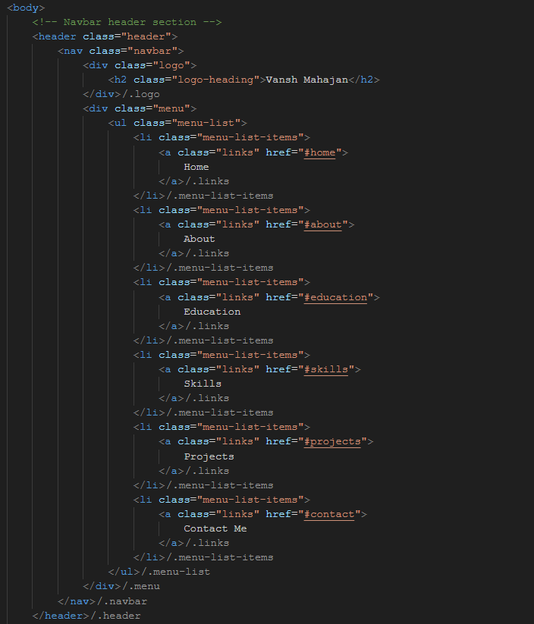

If you click on any of them you will be redirected to that part of the page.

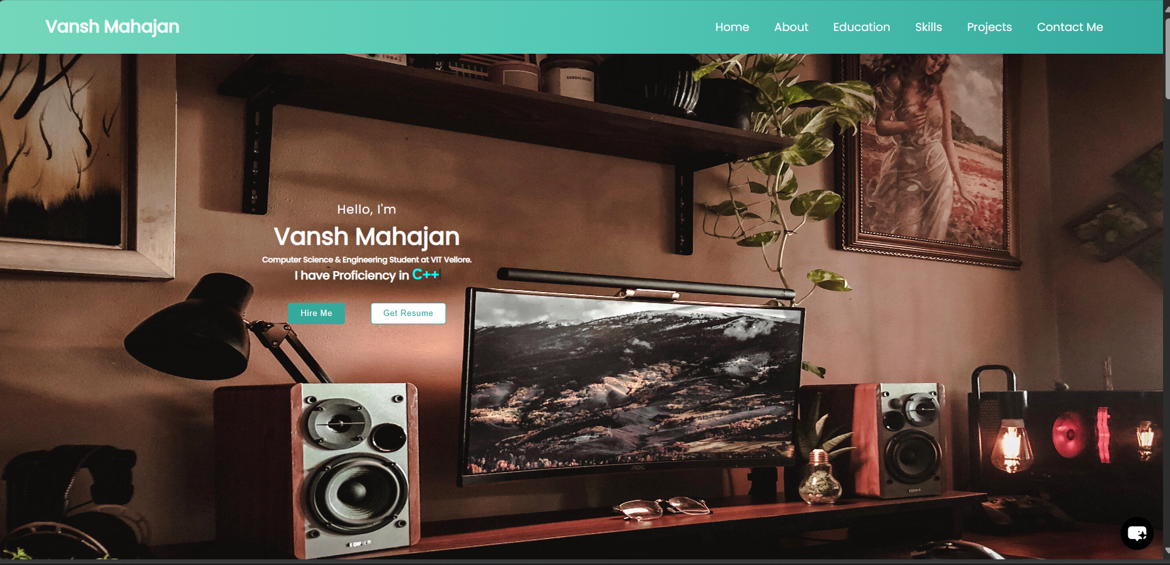

* 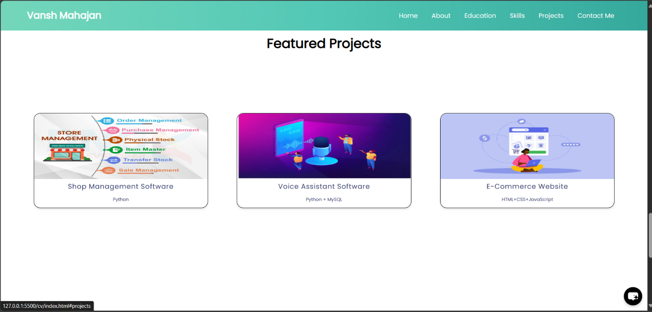For example if you click **“Projects”**  you will be redirected to the section of oage containing my **“Featured projects”.**

1. 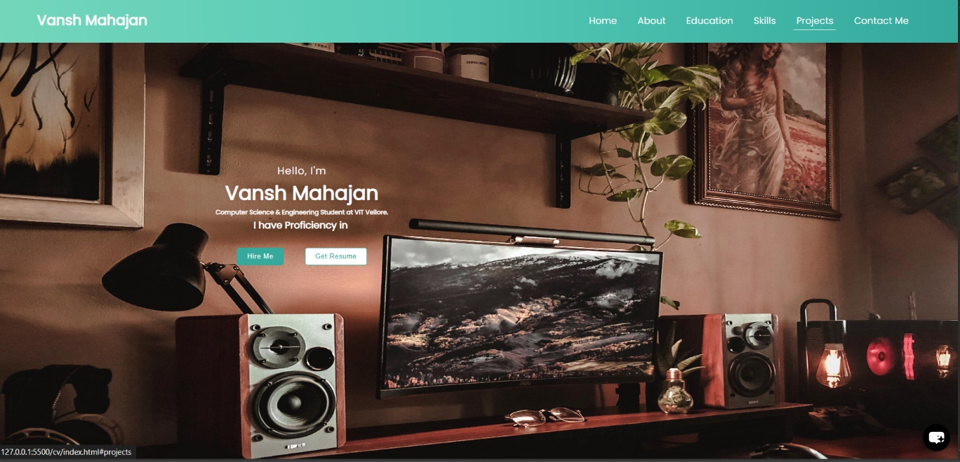**Hero Banner: The hero section features a background image and centered text content, styled with CSS to create an attractive introduction.**
2. **About Section: Information about the website owner is presented with text and an accompanying image, arranged using flexbox for layout control.**

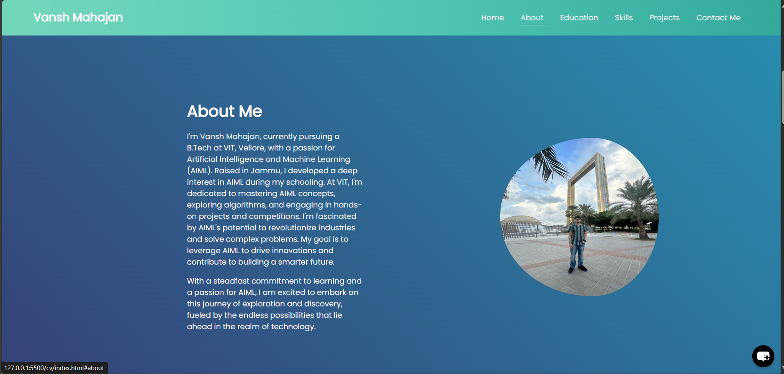

1. **Education Section: A table layout is used to display educational qualifications, enhancing readability and organization of content.** 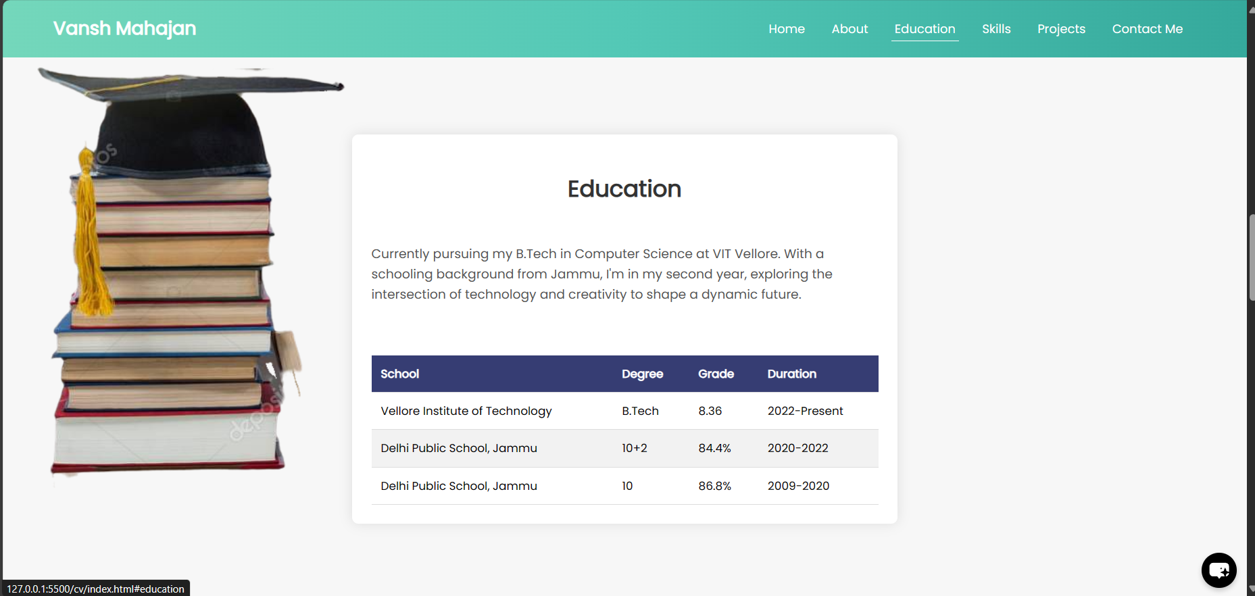
2. **Skills Section: Skills are listed with accompanying progress bars, indicating proficiency levels. Hover effects are added to the skills list items for user interaction.**

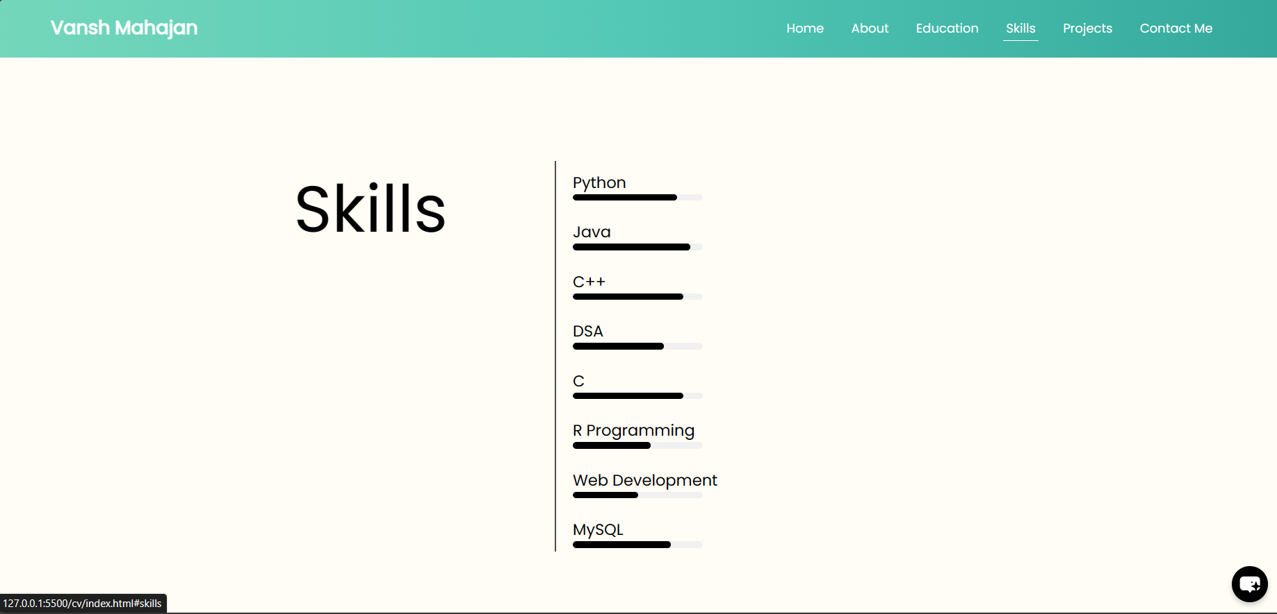

1. **Projects Section: Featured projects are showcased with images and brief descriptions in a grid layout, utilizing flexbox for alignment and styling.**

1. 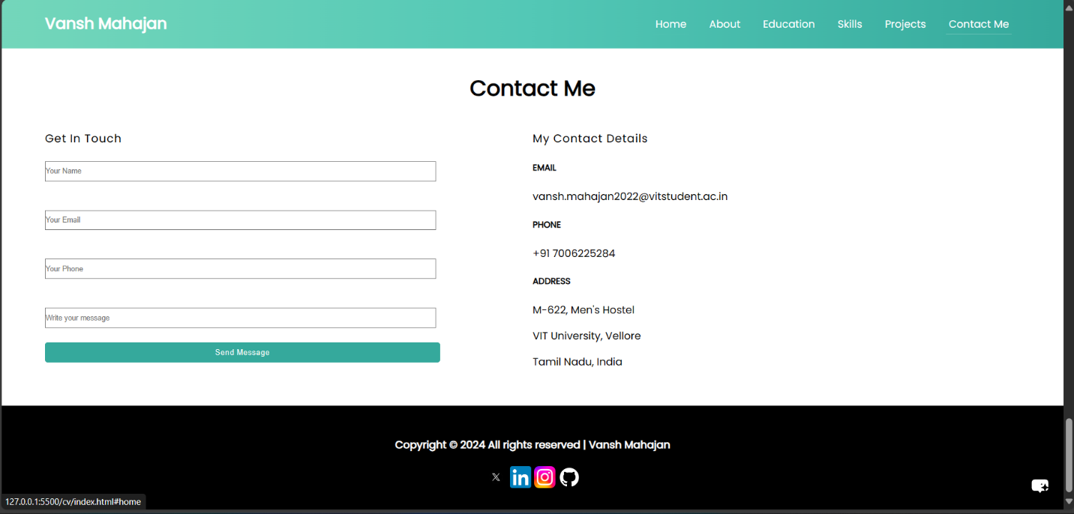**Contact Section: A contact form is provided for users to send messages, with form validation and a modal notification upon successful submission.**
2. 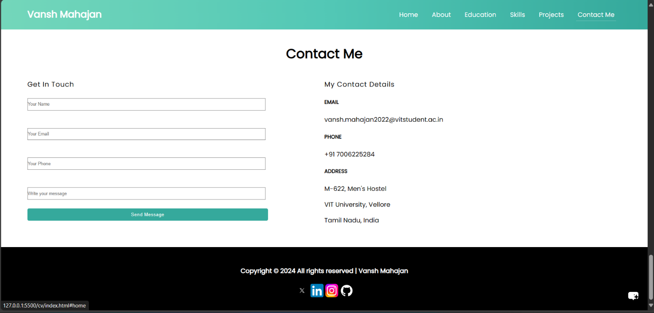**Social Links: Social media links are included in the footer section, allowing visitors to connect with the website owner on various platforms.**
3. **Cursor Animation: The blinking cursor effect is achieved using CSS animations (@keyframes) applied to the ::after pseudo-element of the #head element, simulating a typing animation**



1. **Changing Text: The changing text in the div.intro of the hero section is implemented using JavaScript. The text content is dynamically updated to display different phrases, providing a dynamic and engaging introduction.**

**Interactivity:**

1. **Navigation:** The website features a responsive navigation bar that allows users to easily navigate between different sections such as Home, About, Education, Skills, Projects, and Contact Me.
2. **Smooth Scrolling:** Clicking on navigation links smoothly scrolls the page to the corresponding section, enhancing user experience.
3. **Hover Effects:** Hovering over menu items and project cards triggers visual effects such as color changes and scaling, providing feedback to user interactions.

* Hover effect on “**Hire”** and **“Get resume buttons”:**

**Before : On Hover:**

 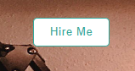

**Before : On Hover:**

 

Achived by simple css (hover):

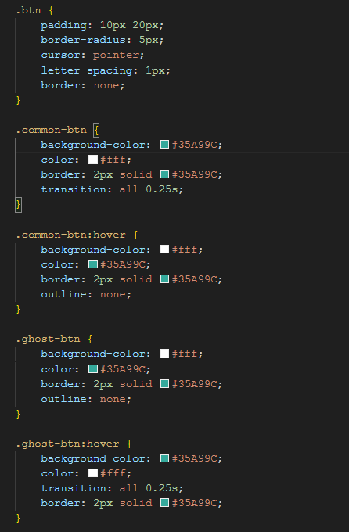

* Hover effect on “**Nav buttons”:**

**Before :**



**On Hover: (An underline appears so you can keep track of what you are selecting)**



Achived by simple css (hover):

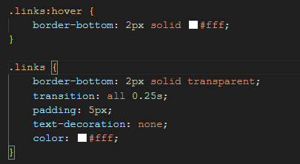

* Hover effect on “**Education Table”:**

**Before : On Hover: (The coloum you hover over**

**becomes a little shadier)**

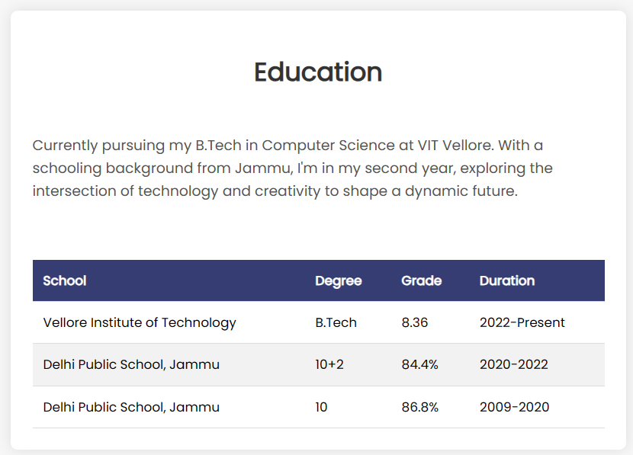

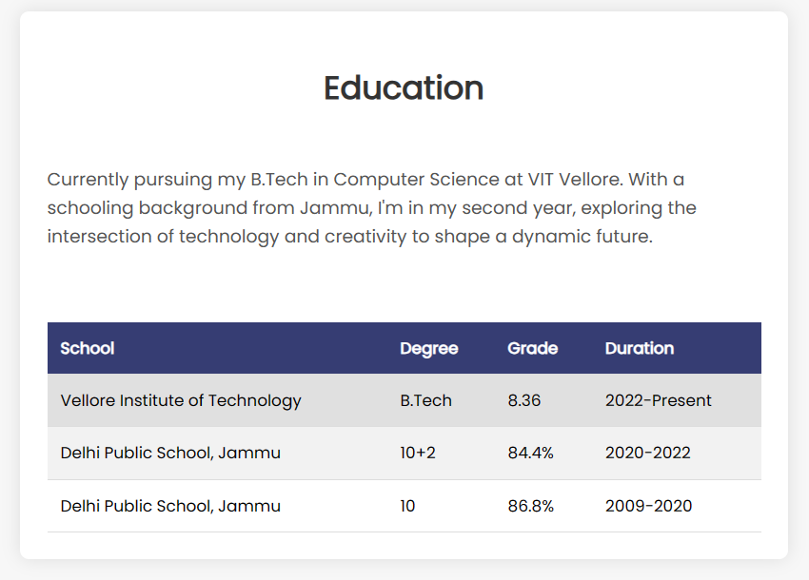

Achived by simple css (hover):

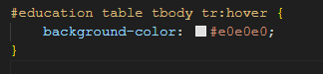

* Hover effect on “**Progress bar”:**



Achived by simple css (hover):

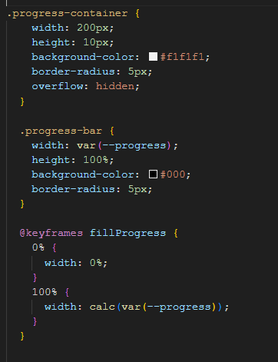

* Hover effect on “**Progress bar”:**



Achived by simple css (hover):

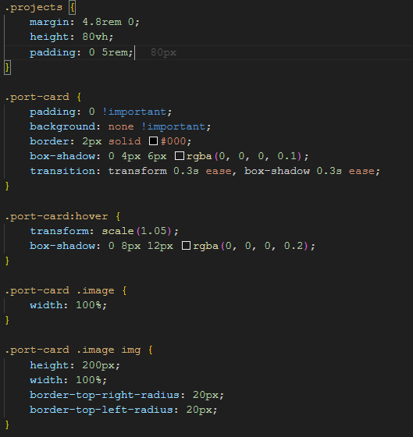

* Hover effect on “**Send Button”:**

**Before :**



**On Hover: (It Becomes hollow)**



Achived by simple css (hover):

Html:



CSS:

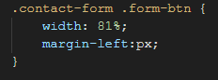

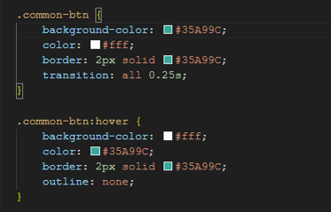

1. **Form Submission:** Upon submitting the contact form, users receive a confirmation message displayed in a modal window, indicating successful message delivery.
2. **Get Resume:** When the button is clicked we get a pdf form of my resume that is stored in local storage under the name “resume.pdf”



Achived by Advanced JavaScript:

HTML: 

JavaScript:

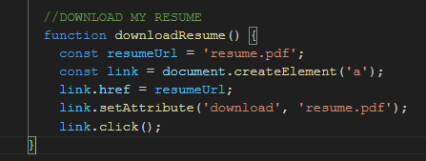

Explanation:

* Firstly, we are setting the address of the PDF file we want to download. Think of it like telling the computer where to find the file.
* Then we're creating a special clickable link on the webpage, just like those you click to navigate to other pages on the internet. (<a> element)
* After that we're telling that link where it should take us when clicked, which in this case is the PDF file.
* Then we specify that when someone clicks this link, the browser should download the file instead of just opening it in the browser window.
* By link.click(), We're telling the computer to pretend like someone clicked on that link, so it starts the download process automatically.

In conclusion,

The download attribute is set directly on the anchor element (link). Then, the click() method is called directly on the anchor element, which initiates the download of the file specified by the href attribute. This approach eliminates the need to append and remove the element from the document body, making the code shorter and more concise.

HTML:



JS:

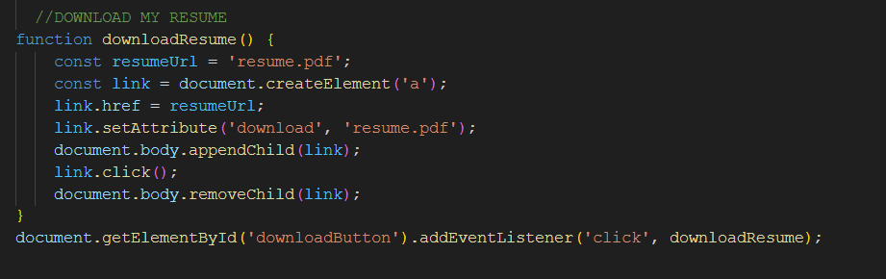

1. **Chat bot: This is in experimental thing I have used an external website “"https://www.chatbase.co/embed.min.js"”**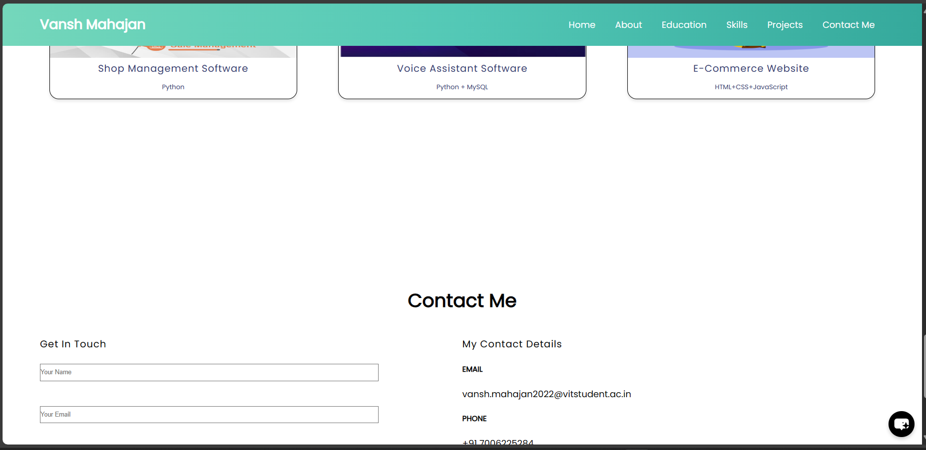

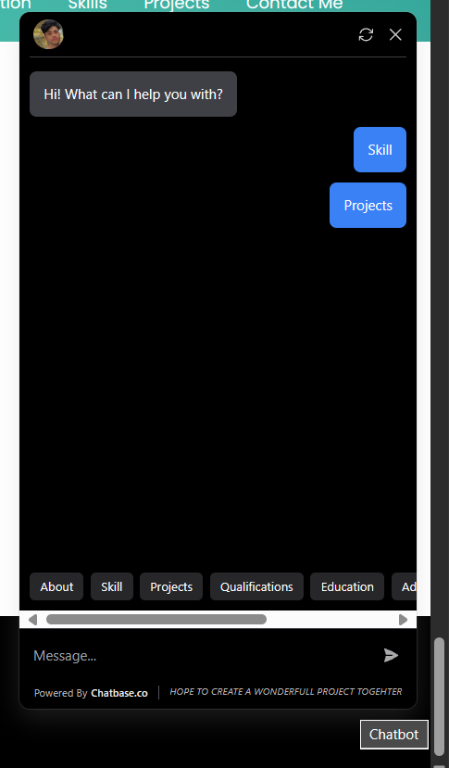

**You can interact with the chat bot and you can also use the pre defined (recommended) messages given below (About skill Projects Qualifications Education Contact email etc.)**

**Overview:**

1. **Home:** The homepage introduces Vansh Mahajan and provides buttons for hiring and downloading his resume.
2. **About:** This section offers a detailed overview of Vansh's background, interests, and academic pursuits.
3. **Education:** Vansh's educational journey, including his current pursuit of a B.Tech in Computer Science at VIT Vellore, is showcased here.
4. **Skills:** Vansh's proficiency in various programming languages and technologies is visually represented using dynamic progress bars.
5. **Projects:** Featured projects, including Shop Management Software, Voice Assistant Software, and E-Commerce Website, are highlighted with brief descriptions.
6. **Contact Me:** Visitors can get in touch with Vansh via a contact form or find his contact details for direct communication.

**Conclusion:** Overall, the portfolio website effectively showcases My skills, experiences, and projects in a visually appealing and interactive manner. It provides a seamless user experience and serves as a valuable tool for potential employers, collaborators, and anyone interested in learning more about me and his work.

**Output Images:**

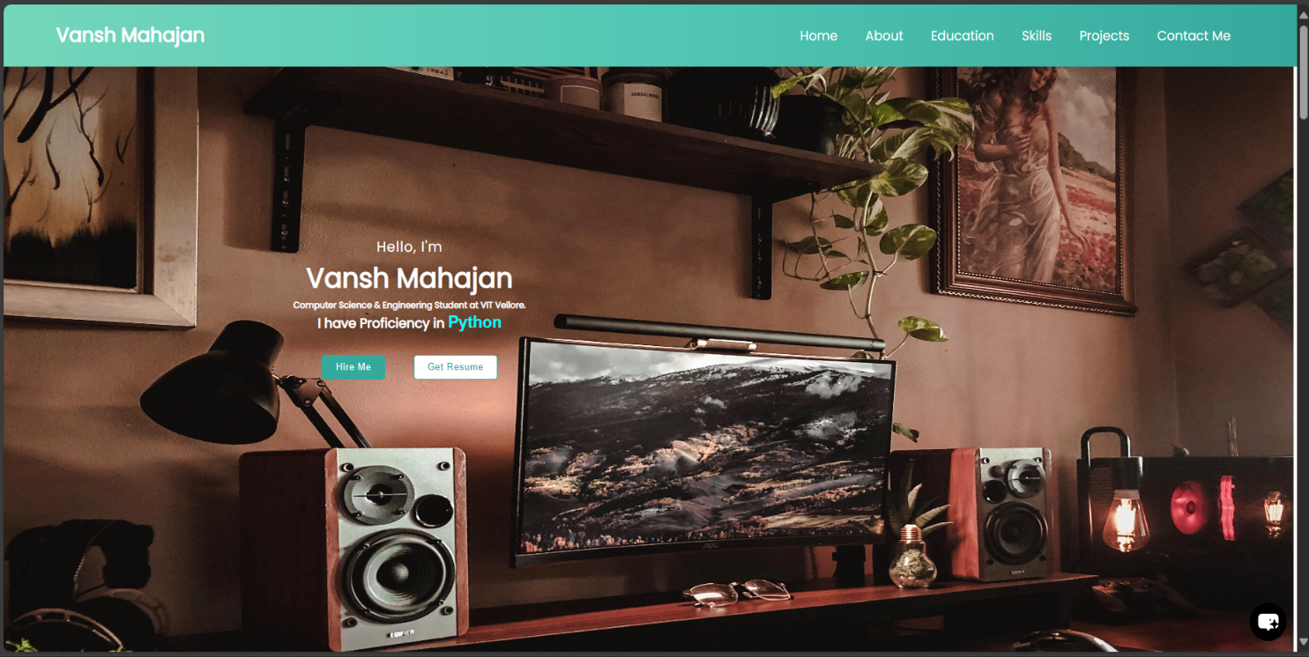

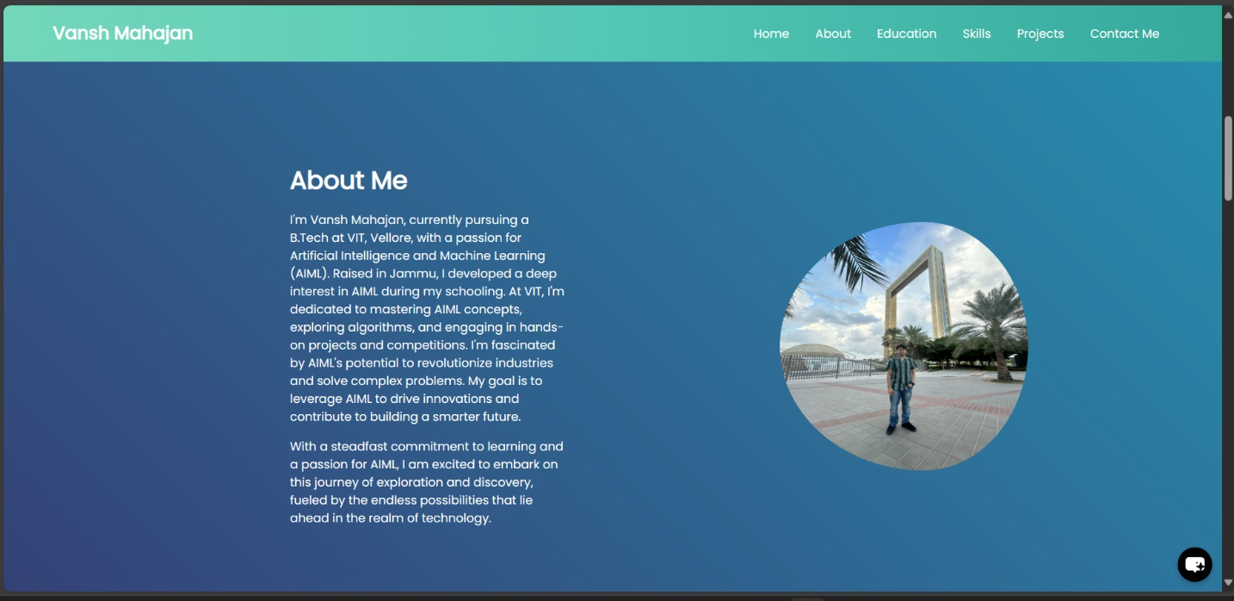

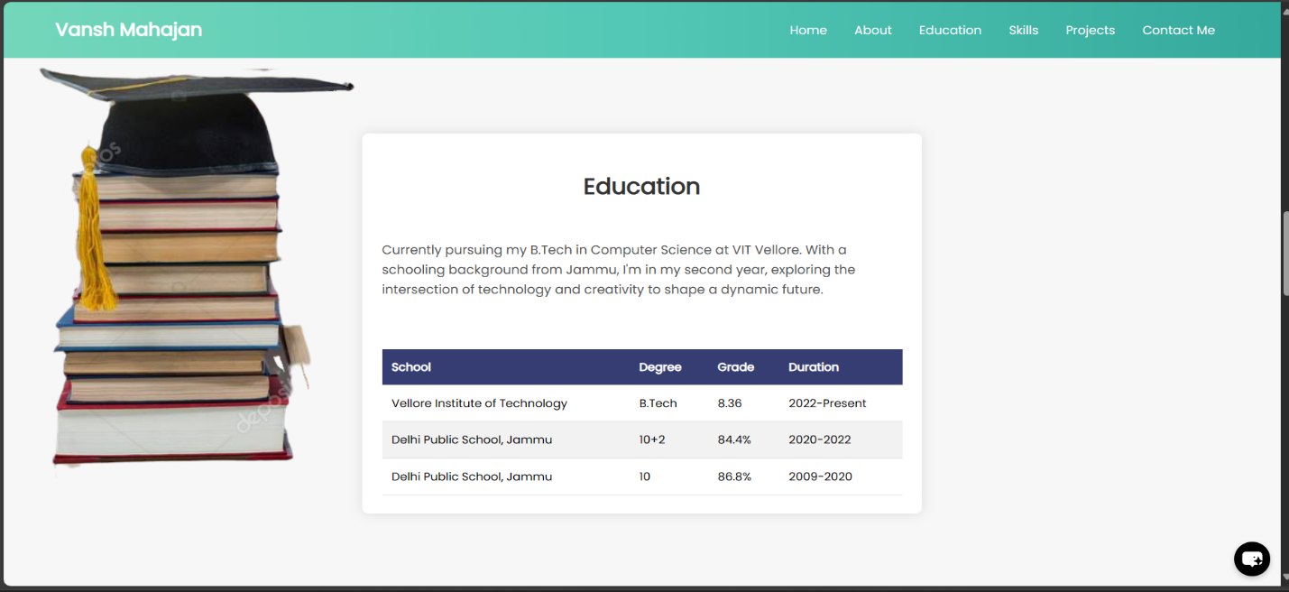

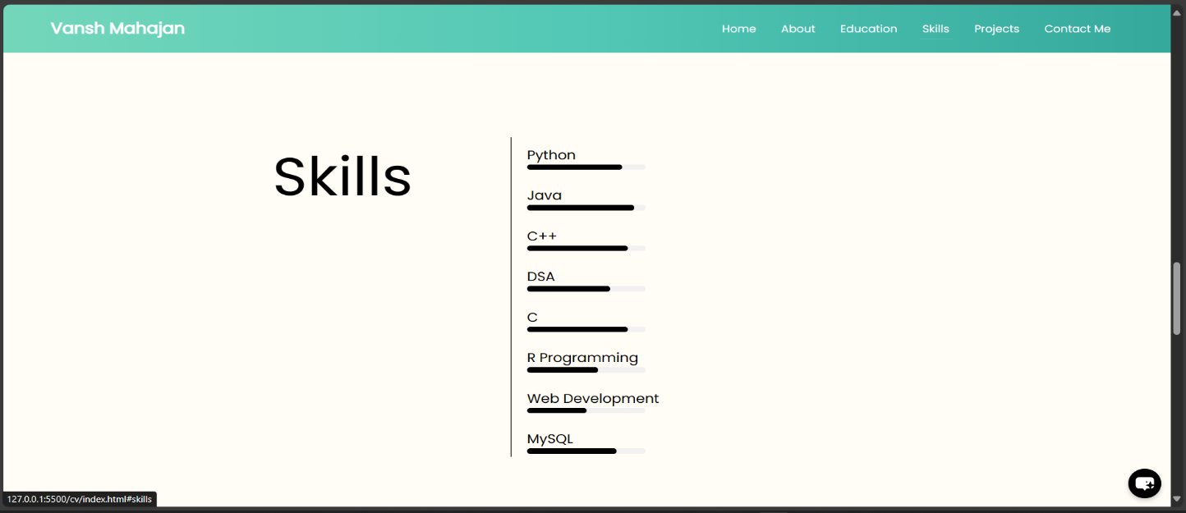

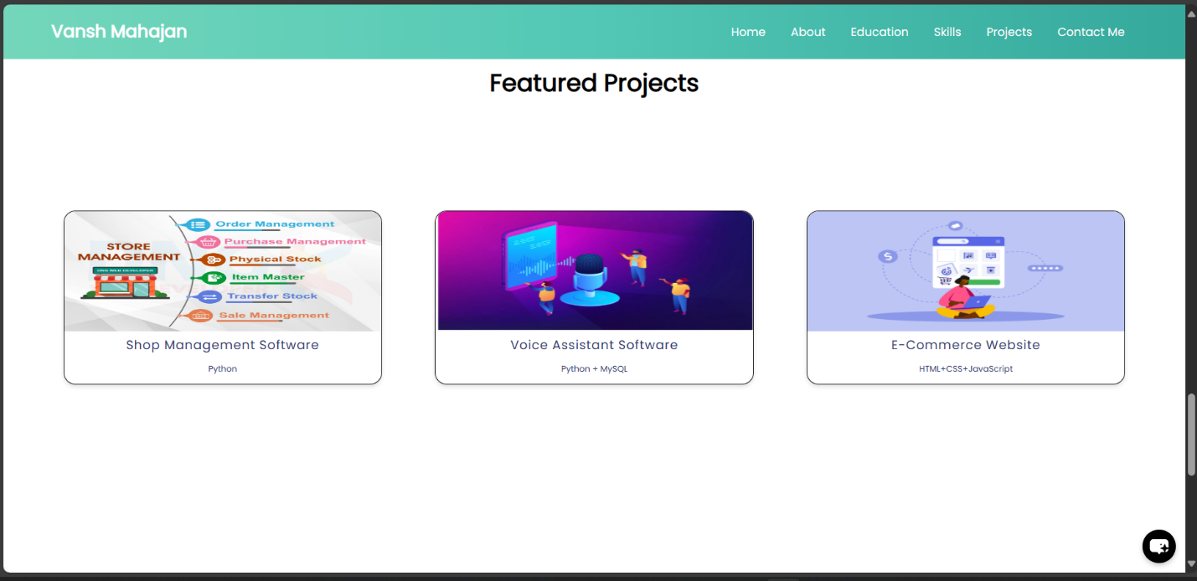

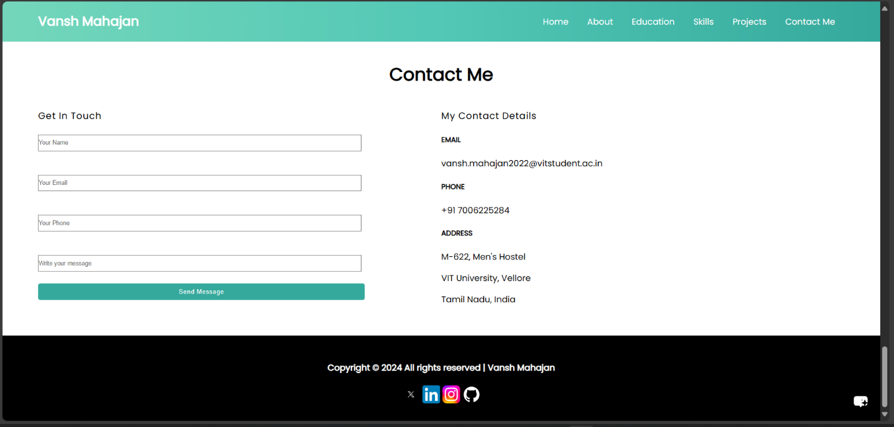

**Snapshot of code:**

 